Nick Cardamone

ncard024@uottawa.ca

300060019

Dec 11, 2020

lab Five: Rectangular Waveguides

Electromagnetic Engineering ELG 3106A

# Introduction

When working with electrical systems in the mmWave frequencies, it is often necessary to use components with waveguide interfaces to avoid high ohmic power losses associated with copper transmission lines at high frequencies. These waveguides are essentially hollow metal boxes with specific dimensions that are related to their supported frequency of operation. In general, the smaller the waveguide aperture, the higher the intended frequency band of the waveguide.

In this lab, we will be looking at the electric and magnetic fields in a rectangular waveguide operating at 10 GHz.

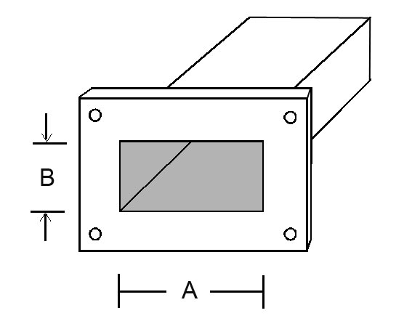

Figure : Waveguide Drawing Figure 2: Real Waveguides

# Theory

Waveguides are a rather complex type of transmission line, and as such, the equations governing the waveguide system are plentiful and cumbersome. Instead of writing pages explaining them, they are summarized in the following table.

Table : Waveguide Equations

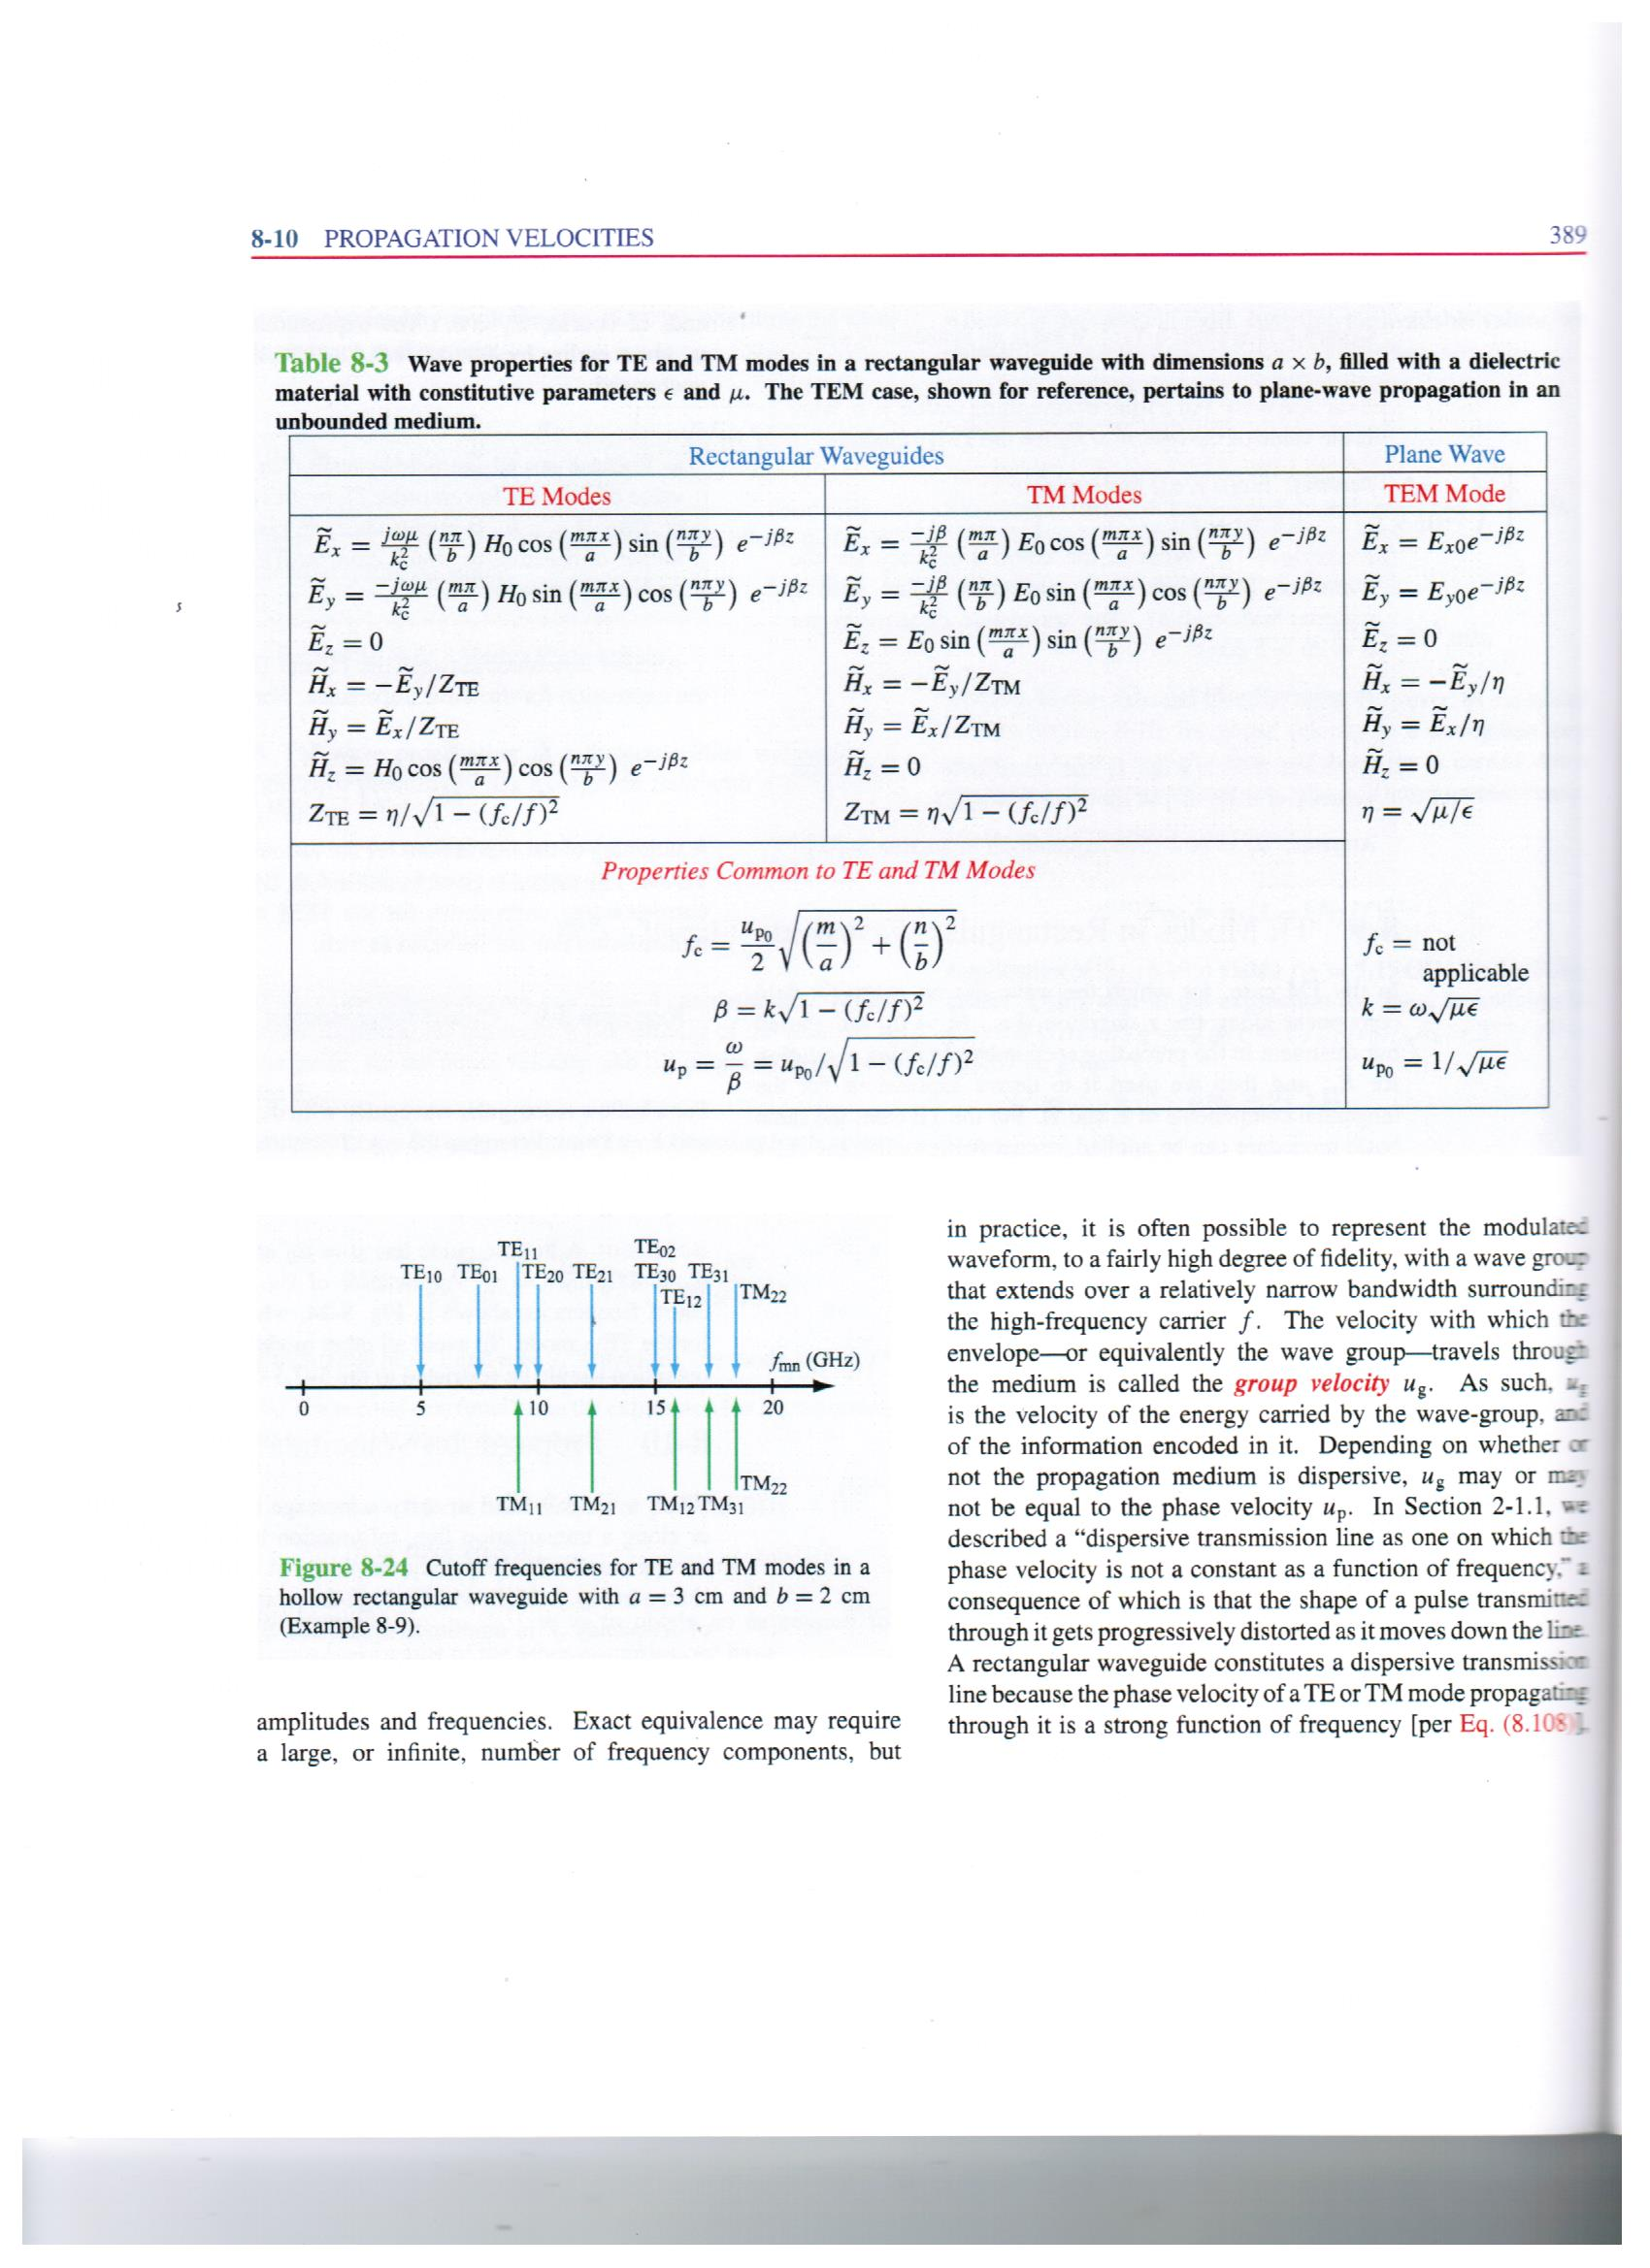

The first part of this lab deals with the dispersion relationship within the waveguide. This relationship is about the propagation velocities and phase shifts as a function of frequency, a kind of frequency response. One key takes away from studying this relationship is that every waveguide acts as a high pass filter, with an associated cut off frequency.

As it turns out, a waveguide can have more than one cut-off frequency, but each of those corresponds to a different propagation pattern of the electric and magnetic field within the waveguide, a kind of spatial harmonic phenomenon. These spatial harmonics are called “modes,”; and they come in two orthogonal flavours, the transverse electric (TE) and transverse magnetic (TM). Each TM and TE mode is described by two integer numbers, “m” and “n.” These give information on which spatial harmonic is present in the mode and in what direction.

The different cut off frequencies for an example waveguide are shown below.



Figure : Cut off Frequencies for a Rectangular Waveguide (a = 3 cm, b = 2 cm)

The cut-off frequencies that land on one another signify degenerate modes. That means they have the same propagation velocity. This allows for power coupling between degenerate modes. Sometimes power coupling is a good thing (say in a directional coupler), and sometimes it is not. Ordinarily, though, modes can not couple power to one another.

The only equation that is not covered in table one is the Poynting vector. This describes the flow of power per square meter of an EM wave. To find this quantity, take the cross product of the electric field phasor and complex conjugate magnetic field phasor. Then take half the real component of that result.

# Results

## Part One

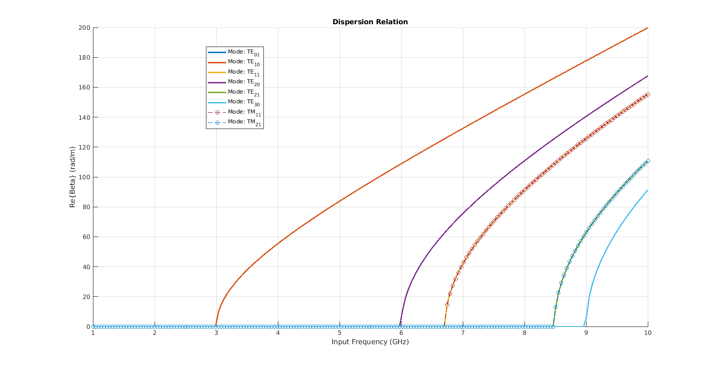

Figure : Waveguide Dispersion Relation -- 2D

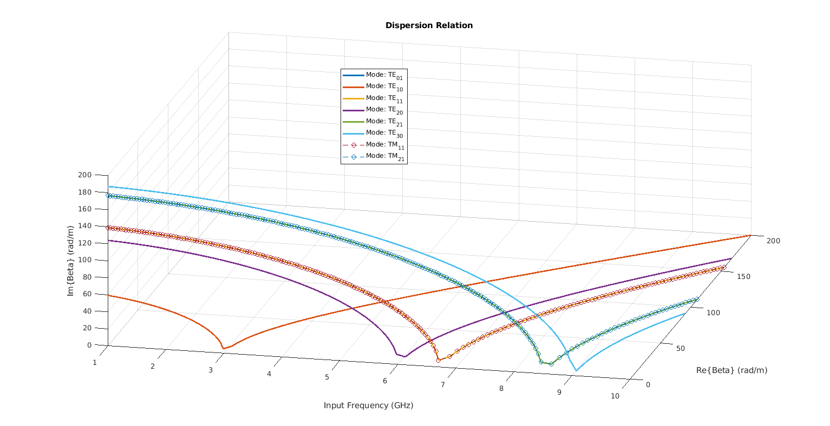

Figure : Waveguide Dispersion Relation -- 3D

## Part Two

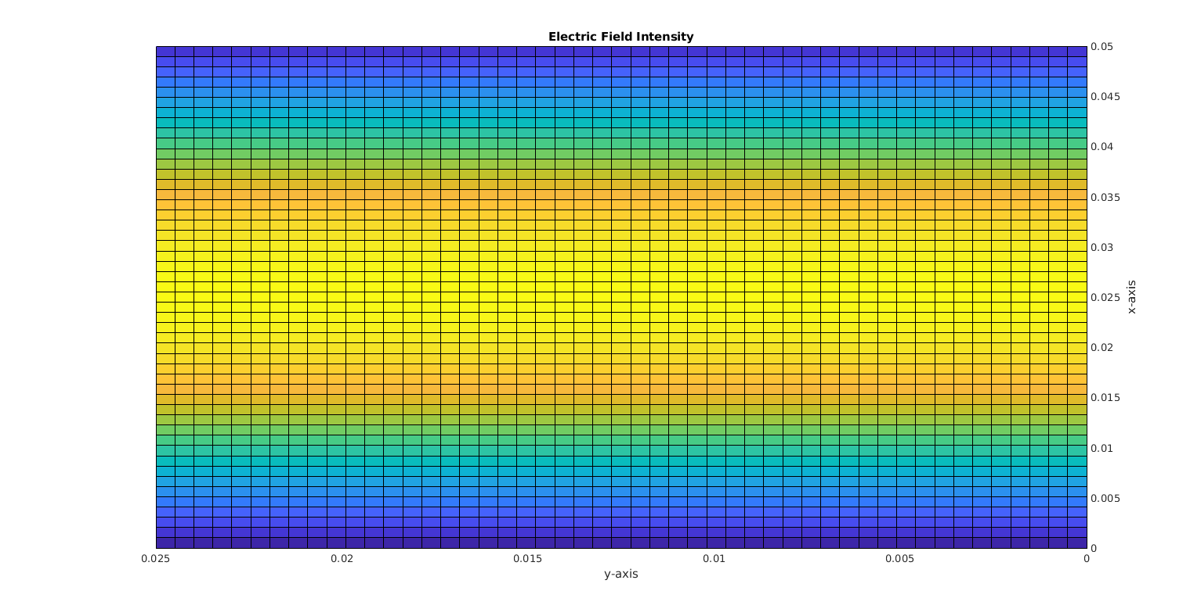

Figure : Electric Field Phasor Intensity – 2D

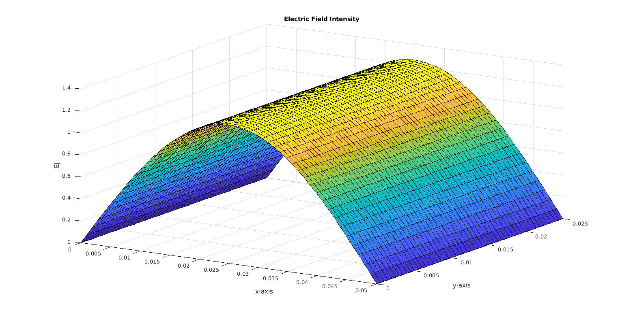

Figure : Electric Field Phasor Intensity – 3D

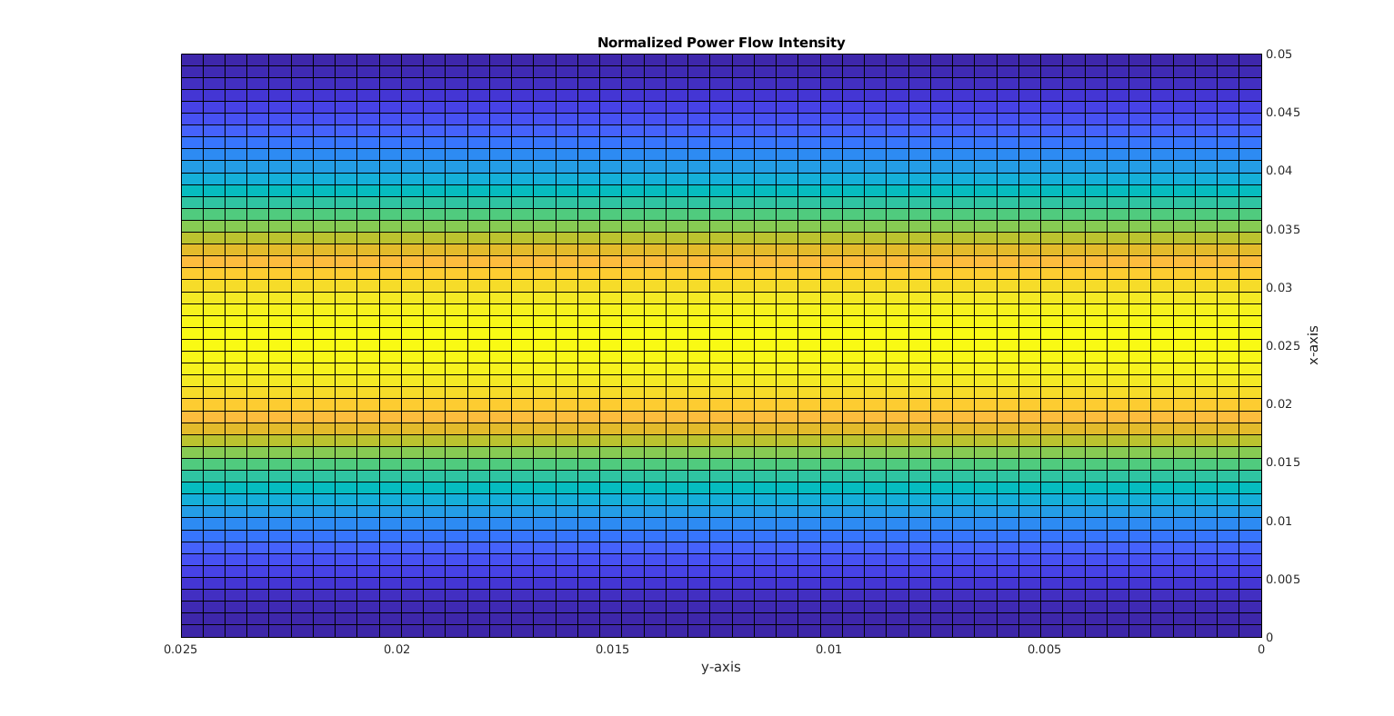

Figure : Normalized Power Flow Intensity -- 2D

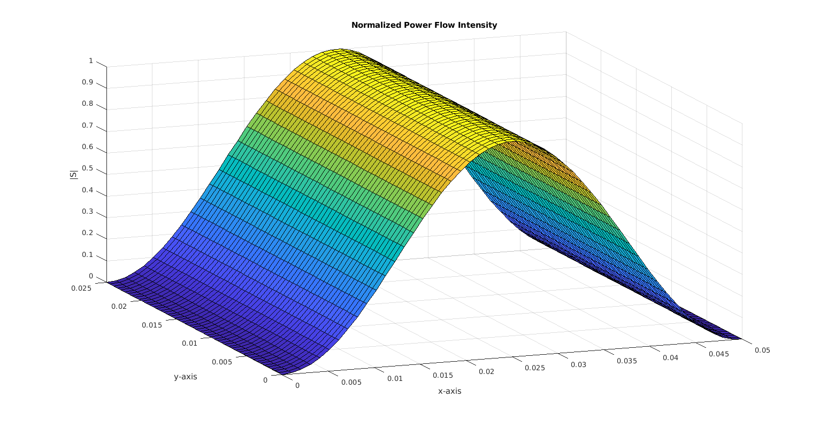

Figure : Normalized Power Flow Intensity -- 3D

## Part Three

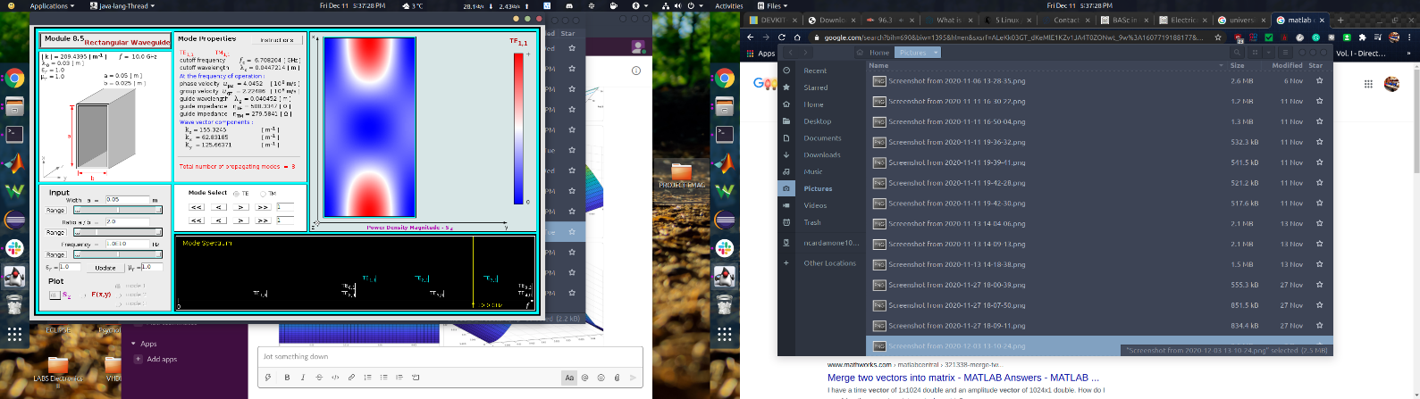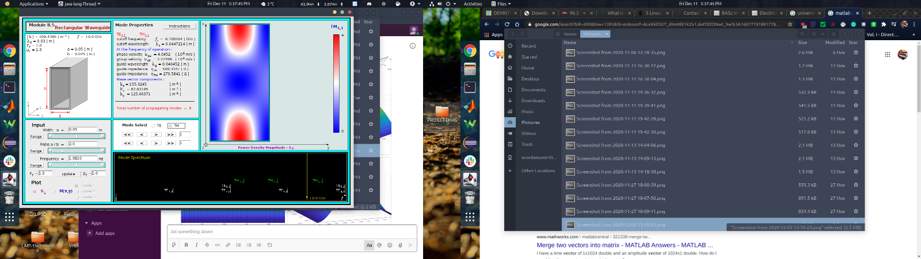

Figure : S -- TE11 Figure 11: S --TM11

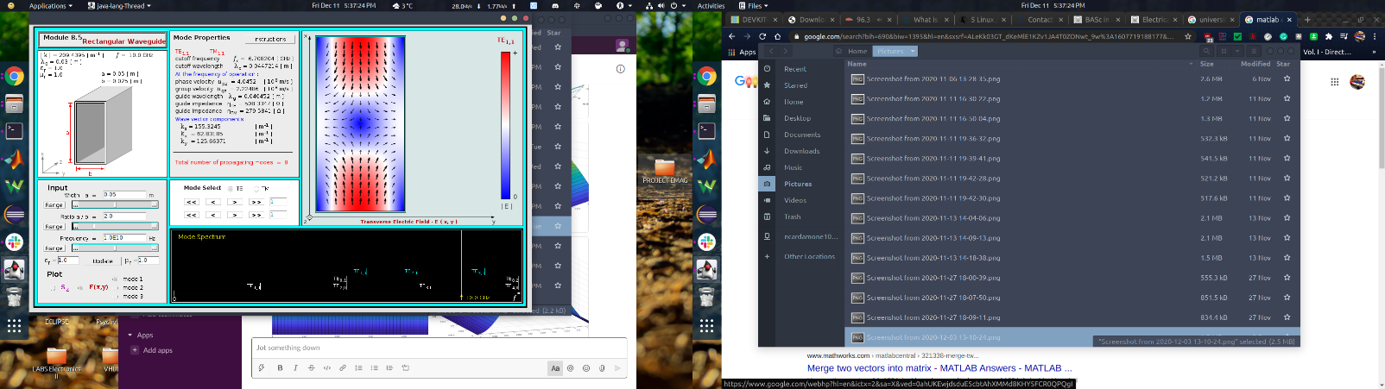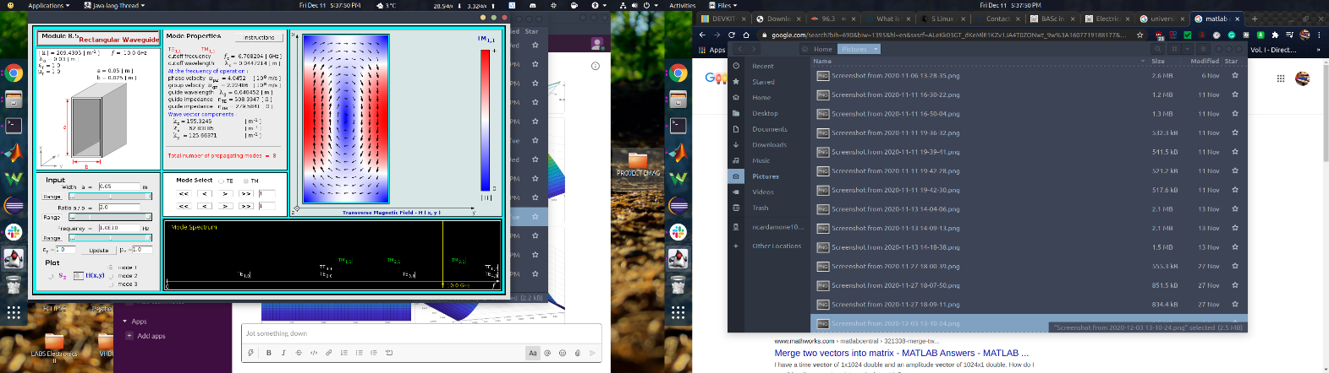

Figure 12: E -- TE11 Figure 13: H --TM11

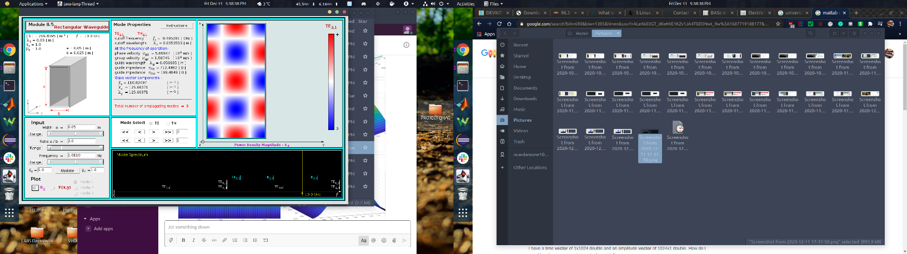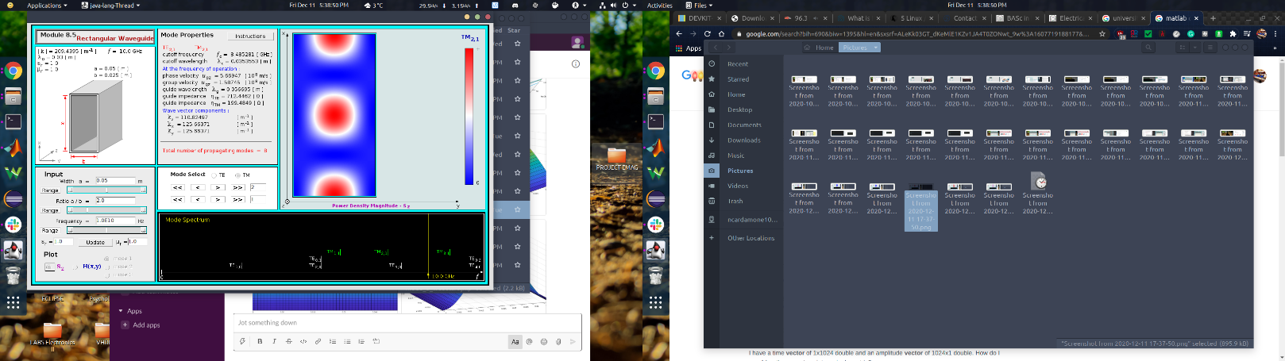

Figure 14: S – TE21 Figure 15: S –TM21

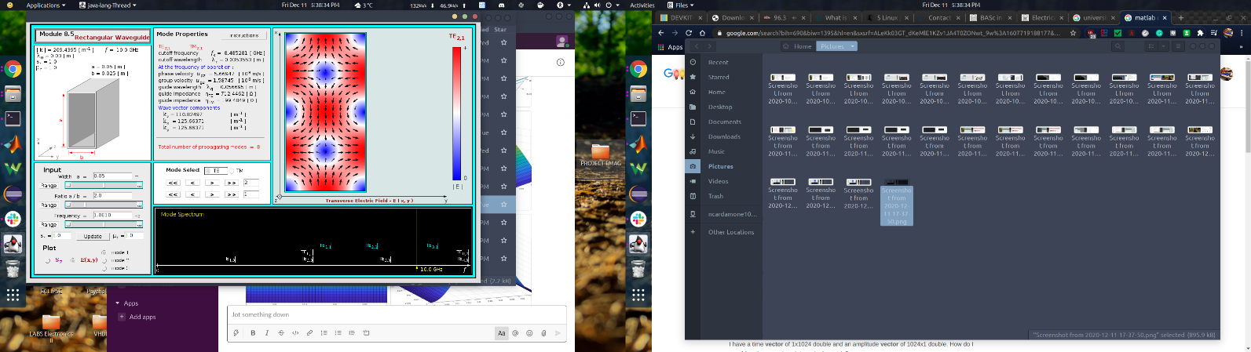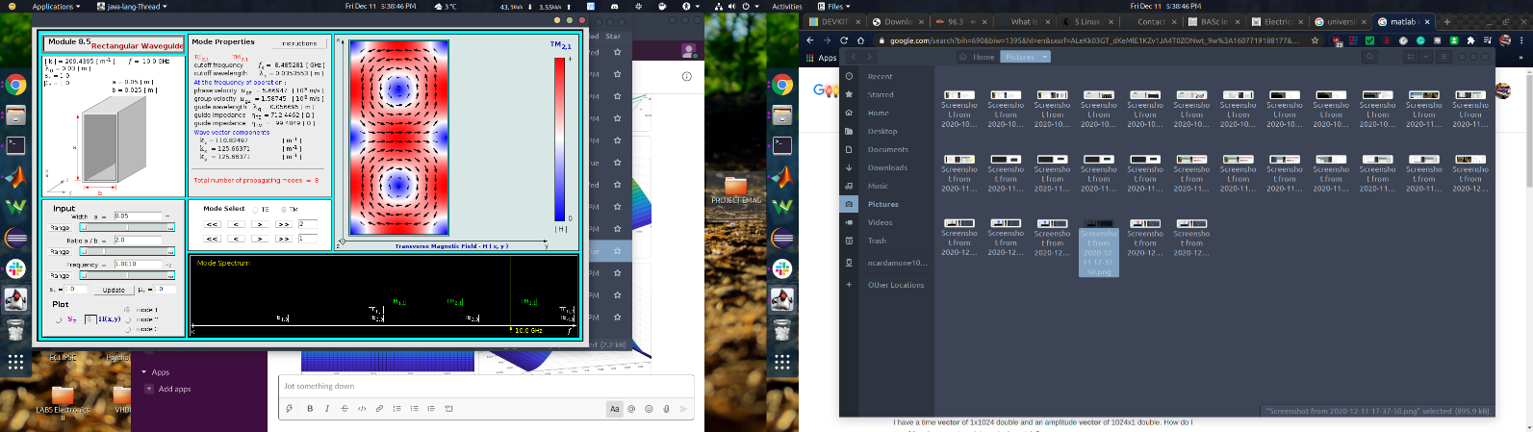

*Figure 16: E – TE21 Figure 17: H –TM21*

# Discussion

## Part One

In part one, there are three pairs of degenerate modes out of the total of 8 that were calculated. They are degenerate because the values of m and n just so happen to produce the same cut-off frequency. One explanation of this is that the cut off frequency does not depend on the polarization of the modes; thus, TE and TM can have degeneracy between them. Another way of looking at it is that similar to a guitar string or CE amplifier; if you put in enough energy, you will get harmonics.

## Part Two

Yes, these plots appear to be correct. When the math is done, the electric field has a sine component in the x-direction, and the Poynting vector has a sine squared component in the x-direction. However, the direction of the actual Poynting vector is in the z-direction, otherwise known as the direction of propagation.

## Part Three

The spatial dependencies of the grouped modes are very similar, but they are orthogonal to each other. It looks like if the modes are degenerate, either the magnitude of the field can be the same shape, or the power density can have the same shape. If two degenerate modes are orthogonal, they can not couple power between them, and the power density will be different. However, if the power densities are the same, then coupling can occur, and the fields are not orthogonal. At least, that is what it looks like from this small sample size.

## Software Explanation

The MATLAB code for this lab became rather complex and messy.

For part one, instead of looking at the first seven possible modes, I decided to write code to find them all. I did that by comparing operating and cut off frequencies. When all the different modes were determined, the TE and TM dispersion relationship was generated and plotted.

For part two, my original intention was to create an animation of the fields propagating. Part of this did work. However, I was not able to get everything to work. As a workaround, I did the math myself to find the sinusoidal relationships to the plot.

# Conclusion

In conclusion, I am exhausted……. There was an observed relationship between the fields, power flow, dispersion relation and cut-off frequencies of the modes. It’s been a long semester….

# Appendix I: MATLAB Code

